HOW TO SECURE WEB APPLICATIONS WITH SSL/TLS CERTIFICATES IN AWS

The pre-requisite for this post is, that the reader must have already deployed his/her application in AWS Elastic Beanstalk environment and the next thing he/she wants to do is to protect the web application using secured certificates. My recommendation would be, please go to the following link for better understanding of the process and then follow the steps given in this document to manage the certificate of your website (in our case [www.informagic.com](http://www.informagic.com)). Then again, if you are in a hurry, let’s follow the steps given below:

<https://docs.aws.amazon.com/acm/latest/userguide/gs-acm-request.html>

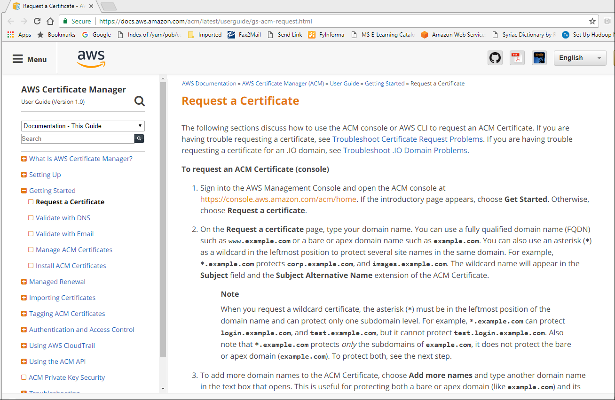

I’m going to keep this simple with the help of screen shots of AWS console.

**Step 1)** Go to AWS services, type certificate manager in a search box and click on “Certificate Manager” from the option list. Since we are going to use AWS Certificate, click on “Request a certificate” button. “Import a certificate” is used for 3rd party certificates. [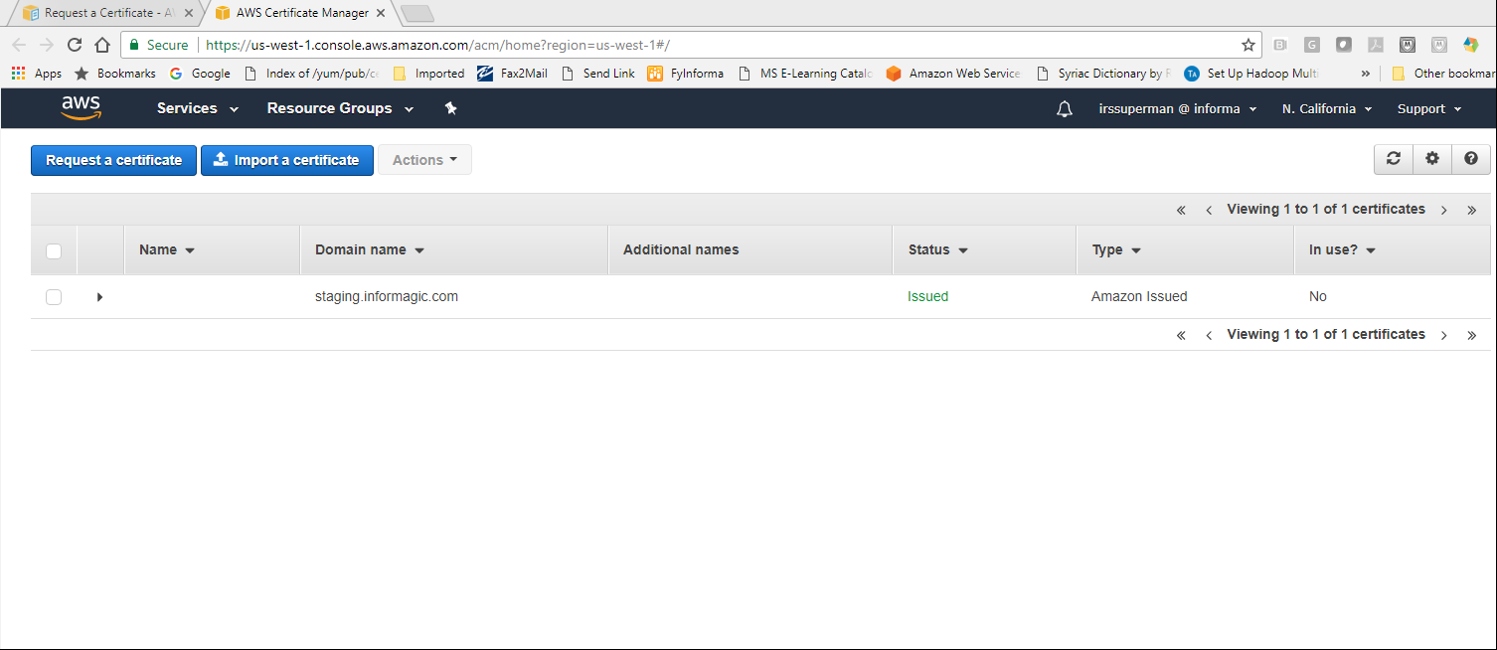](https://console.aws.amazon.com/acm/home)

**Step 2)** Enter domain name of the certificate. You may also add your sub domains or totally another domain to the same certificate by clicking on “Add another name to this certificate”. Click Next.

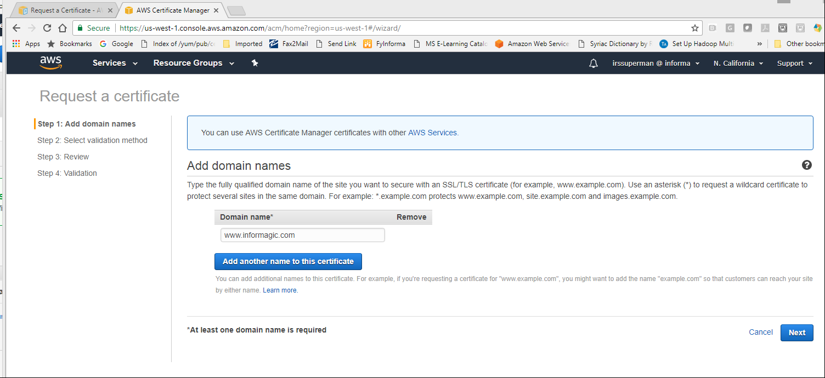

**Step 3)** At this point, make sure you have access to DNS Server and then choose DNS validation. In DNS Server you create canonical name a.k.a. CNAME. Email option is for emailing the person whose email exists on the files at the time of domain registration.

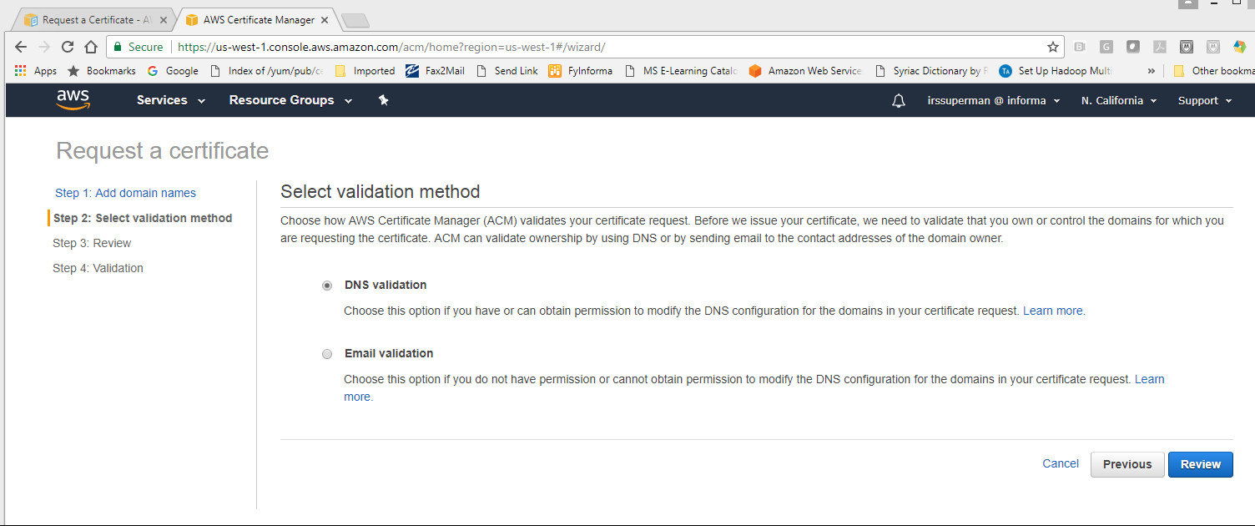

**Step 4)** Review and Confirm your certification request.

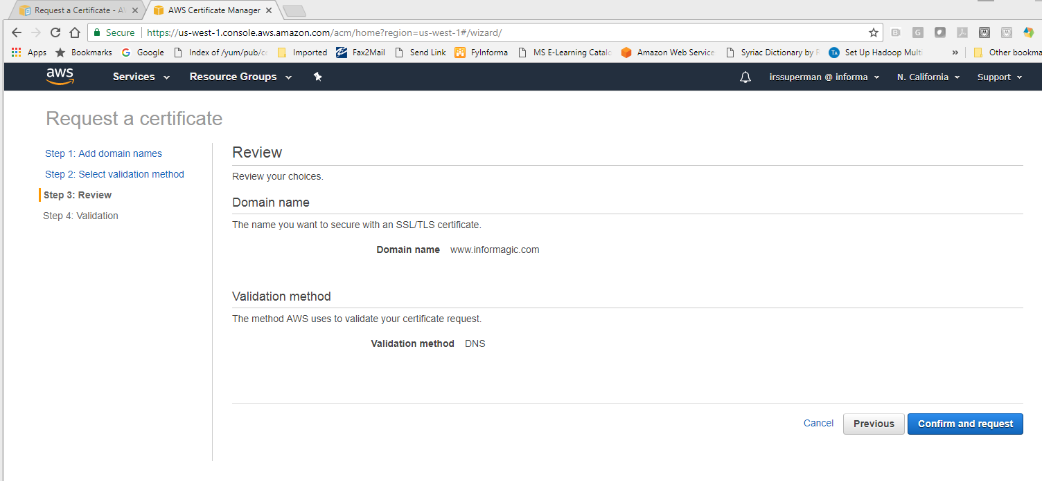

**Step 5)** You may check the cname created here and can also export it, as shown below. Some people will have to wait for longer time, but in my experience, it takes like a minute to propagate and complete this step.

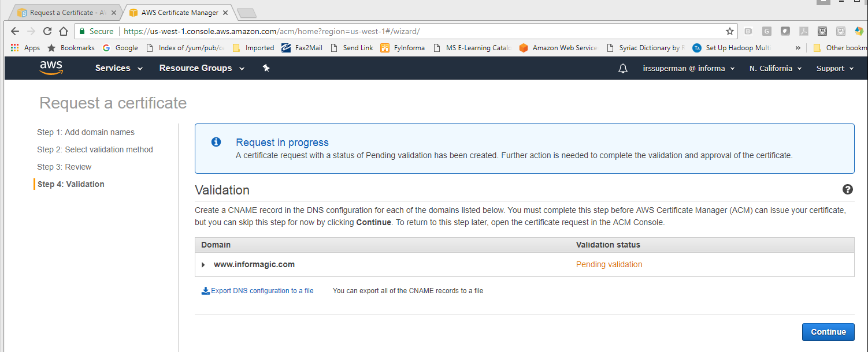

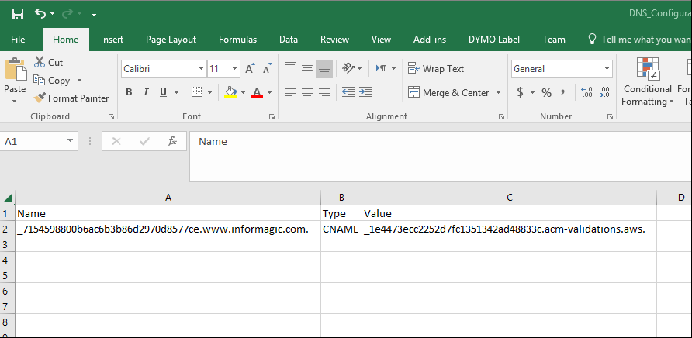

Voila! the certificate is ready to be plugged in to your website. The later part of this post is for the people who are using Amazon Route 53 to host their web sites

**Step 6)** Go to Route 53 in amazon services and on Route 53 console, click “Hosted Zones”. From the list of hosted zones, select [informagic.com](http://www.informagic.com), specifically the public type and create the record set.

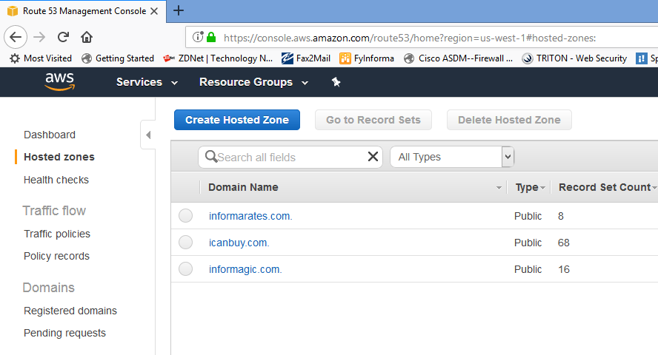

**Step 7)** As you can see in the below image, AWS automatically gives the name to the created record set.

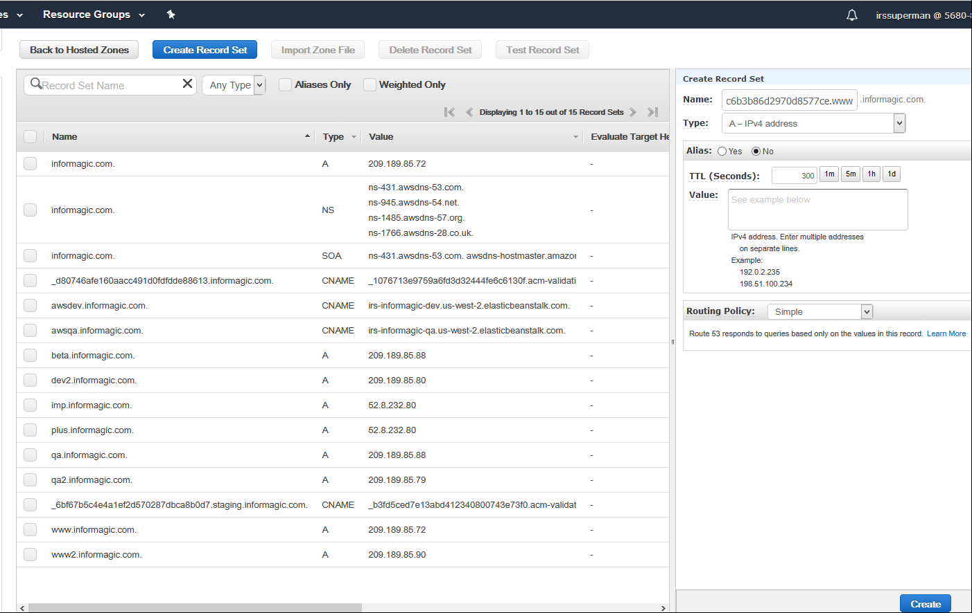

**Step 8)** Under “Create Record Set”, change the type to CNAME and select the Value. Leave the Routing Policy alone for now and click on “Create”.

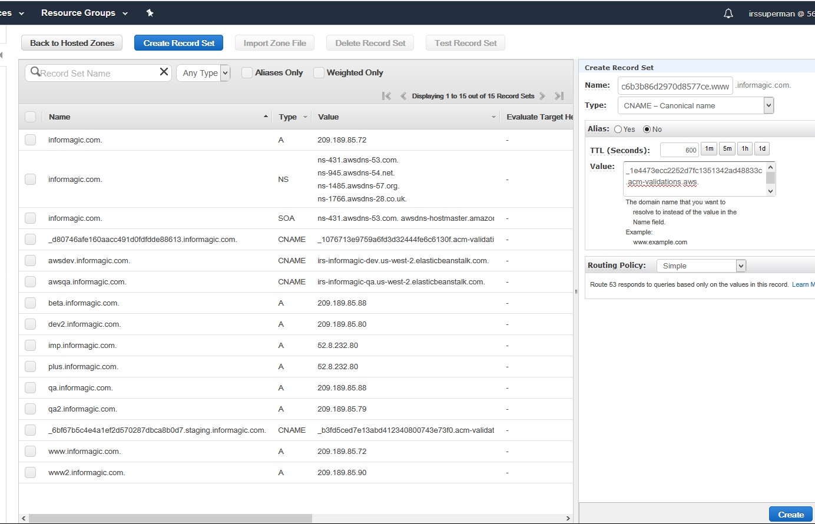

**Step 9)** Save the record set and continue.

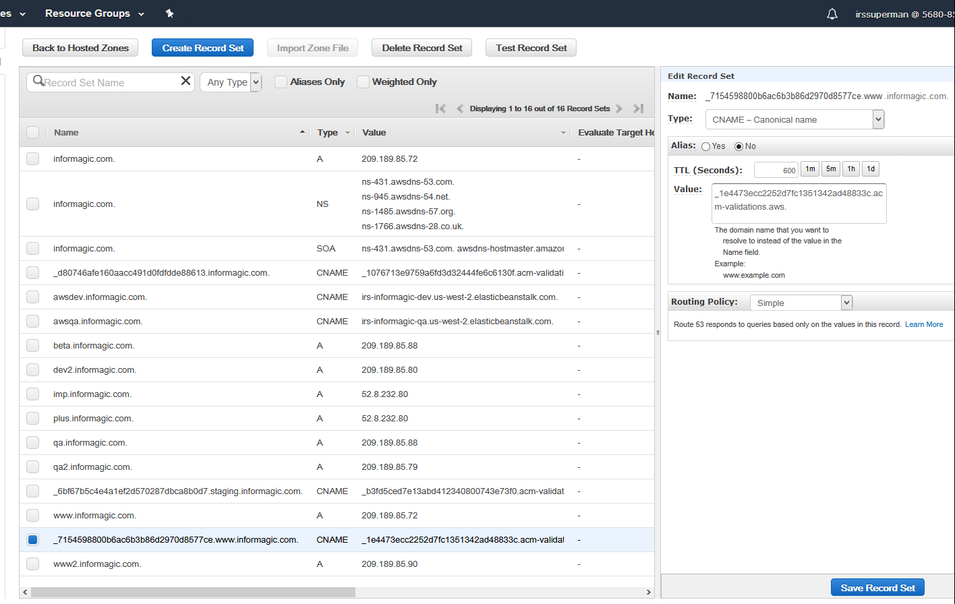

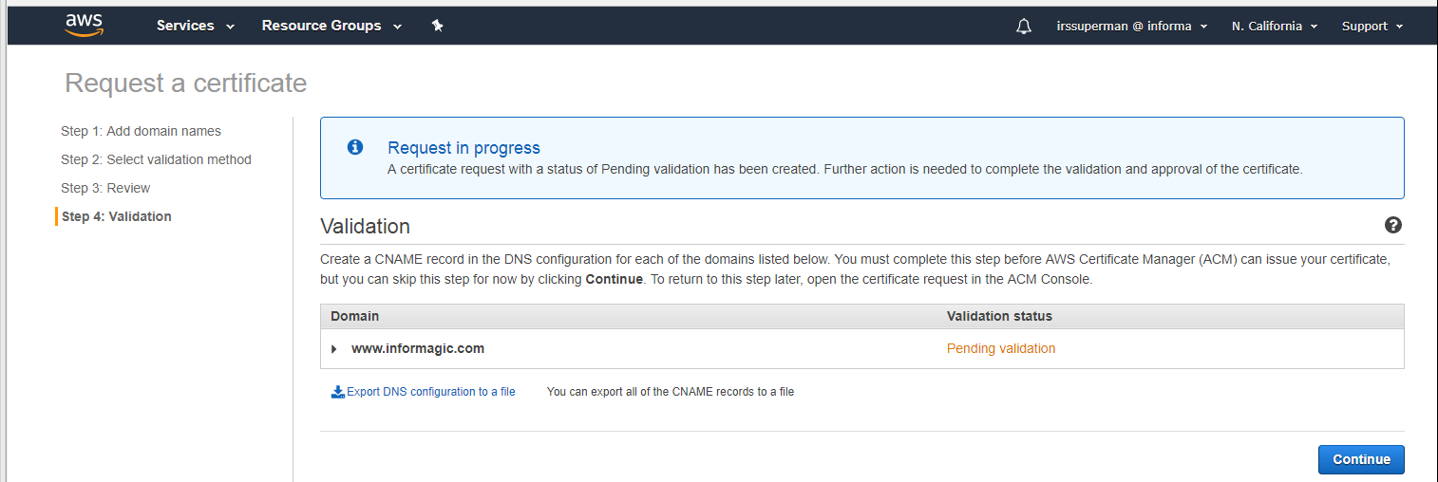

**Step 10)** 😊 Success! Route 53 is beyond the scope of this post, so I guess I’ll stop here and enjoy your secured website.

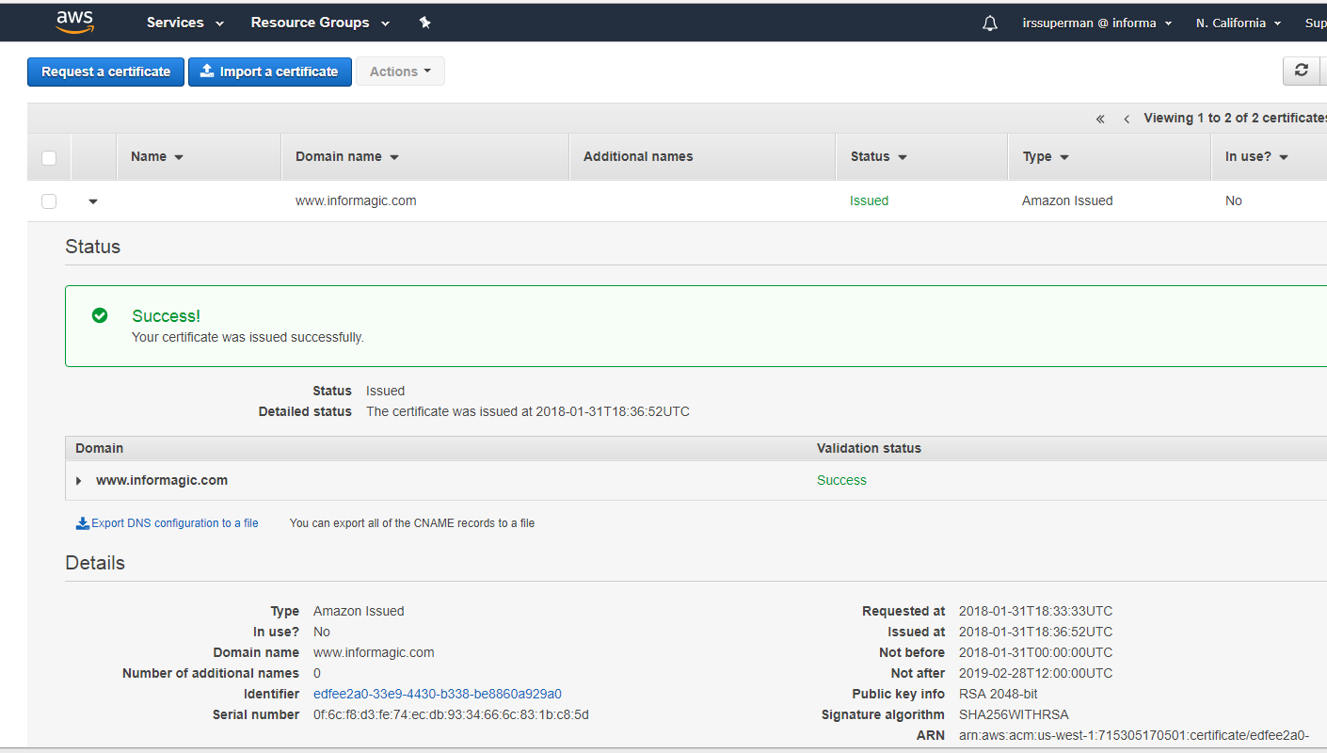

For more information on setting up SSL/TLS certificates on AWS, you can reach me or Isho at [tabish.sayed@informa.com](mailto:tabish.sayed@informa.com) or [isho.callo@informa.com](mailto:isho.callo@informa.com) respectively. Thanks!

-Tabish Sayed